Project Description

I have built an AR face filter with the help of a unity engine and AR foundational for android smartphones.

In this application there are 4 superheroes with you can change your face batman, joker, spiderman, and ironman.

You need an android phone with android version 7 and above to run the application.

Here is the link for the whole project: https://drive.google.com/drive/folders/1v4PftCc2g_jCNr9iUSR6tGKzSLVpcNv6?usp=sharing

For this assessment I have delivered you the following things:

1. Project Description: Details regarding the project
2. Unity Source Code: Source code for the application.
3. Andriod APK: Android executable file in APK extension.

Here are some screenshots of the applications,

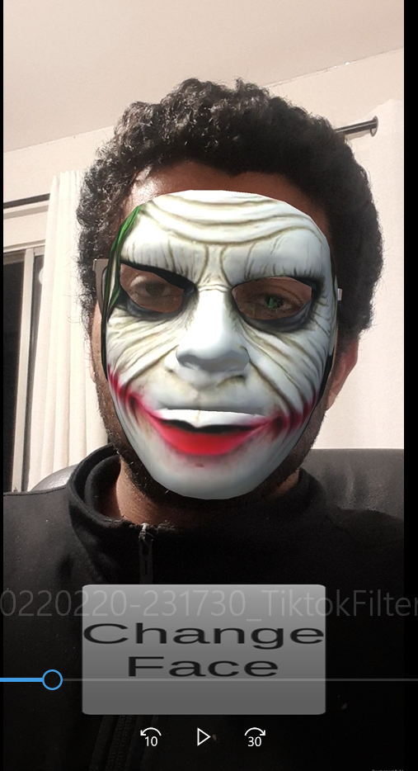 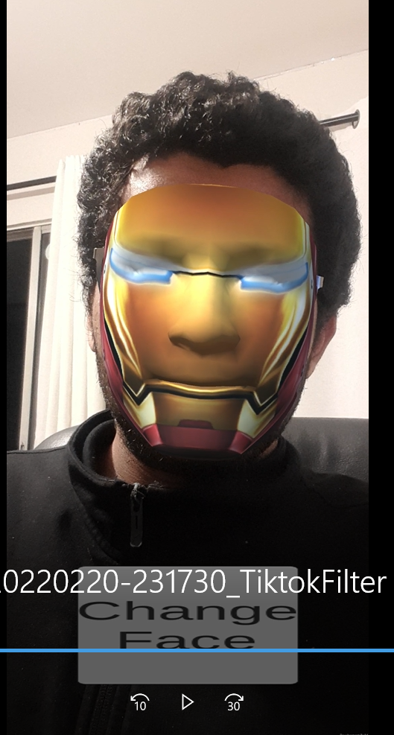

Reference:

1. <https://www.youtube.com/watch?v=5-kpTHO3MpA>
2. https://docs.unity3d.com/Packages/com.unity.xr.arfoundation@4.2/manual/index.html